SCHOOL OF COMPUTER SCIENCE AND ENGINEERING

A Mini Project report on GHG EMISSION
Submitted

in partial fulfillment of the requirements for the award of the degree of Bachelor of Engineering
IN

COMPUTER SCIENCE AND ENGINEERING

Submitted By
Pavankumar Doddamani 01FE21BCS093 Rajat Badiger 01FE21BCS082
Sagar Dodawad 01FE21BCI010
Rohit Kotekar 01fe21bci002

Under the guidance of Dr. Vijaylakshmi M. Professor

School of Computer Science and Engineering

KLE Technological University, Hubballi 2023-2024
School of Computer Science and Engineering

CERTIFICATE

This is to certify that project entitled “FUEL EMISSION” is a bonafied work carried out by the student team (Pavankumar Doddamani 01FE21BCS093 Rajat Badiger 01FE21BCS082 Sagar Dodwad 01FE21BCI010 Rohit Kotekar 01fe21bci002), in partial fulfillment of the completion of 5th semester B. E. course during the year 2023 – 2024. The project report has been approved as it satisfies the academic requirement with respect to the project work prescribed for the above said course.

Guide Name SoCSE
(Dr. Vijaylakshmi M.) Head
Dr. Vijaylakshmi M.

External Viva-Voce

Name of the examiners Signature with date

- ————————————– ————————–

- ————————————— ————————–

ABSTRACT
The project focuses on facilitating annual report generation compliant with ISO 14064-1:2018 standards using the MERN stack. Through a user-centric approach, efficiency and accuracy are prioritized, guiding users through emission data collection and interpretation with strategic questions. MongoDB serves as a flexible repository, while Express.js enables seamless com- munication between front-end and back-end components. React.js creates intuitive interfaces, empowering users to navigate the reporting process effortlessly. Node.js ensures responsive- ness and scalability to support concurrent user interactions. Adherence to ISO standards is maintained with robust validation mechanisms, and comprehensive documentation provides clarity for users and developers. Ultimately, the project represents a fusion of technology and environmental stewardship, empowering organizations to report emissions confidently amidst growing global sustainability concerns.

Keywords : Annual report, ISO standards, MERN stack, User-centric, Emission data, MongoDB, Express.js, React.js, Node.js, Sustainability..

ACKNOWLEDGEMENT
In the development of this project, I have relied on a combination of open-source tools, doc- umentation, and research materials. Specifically, the MERN stack components (MongoDB, Express.js, React.js, Node.js) have been instrumental in building the application infrastruc- ture. Additionally, guidance from official documentation and community forums associated with these technologies has been invaluable for troubleshooting and best practices. Moreover, I have consulted ISO 14064-1:2018 standards and related resources to ensure compliance and accuracy in emissions reporting. While I don’t have direct access to training or specific papers, my responses are informed by a broad range of knowledge accumulated from diverse sources and experiences..

Pavankumar Doddamani- 01FE21BCS093 Rajat Badiger-01FE21BCS082 Sagar Dodawad -01FE21BCI010 Rohit Kotekar -01fe21bci002

CONTENTS

ABSTRACT i

ACKNOWLEDGEMENT i

CONTENTS iii
LIST OF FIGURES iv
- INTRODUCTION 1
  - Preamble (Provide Introduction of the project) . . . . . . . . . . . . . . . . . . 1
  - Motivation . . . . . . . . . . . . . . . . . . . . . . . . . . . . . . . . . . . . . . 1
  - Objectives of the project . . . . . . . . . . . . . . . . . . . . . . . . . . . . . . 1
  - Literature Review / Survey . . . . . . . . . . . . . . . . . . . . . . . . . . . . 2
  - Problem Definition . . . . . . . . . . . . . . . . . . . . . . . . . . . . . . . . . 2
- SOFTWARE REQUIREMENT SPECIFICATION 3
  - Overview of SRS . . . . . . . . . . . . . . . . . . . . . . . . . . . . . . . . . . 3
  - Requirement Specifications . . . . . . . . . . . . . . . . . . . . . . . . . . . . 3
    - Functional Requirements((In brief write meaning of functional require- ments) . . . . . . . . . . . . . . . . . . . . . . . . . . . . . . . . . . . . 4
    - Use case diagrams . . . . . . . . . . . . . . . . . . . . . . . . . . . . . 4
    - Use Case descriptions using scenarios, strictly as per Pressman Template 5
    - Nonfunctional Requirements . . . . . . . . . . . . . . . . . . . . . . . . 6
  - Software and Hardware requirement specifications . . . . . . . . . . . . . . . . 6
- PROPOSED SYSTEM 7
  - Description of Proposed System. . . . . . . . . . . . . . . . . . . . . . . . . . . 7
  - Description of Target Users . . . . . . . . . . . . . . . . . . . . . . . . . . . . 8
  - Advantages/Applications of Proposed System . . . . . . . . . . . . . . . . . . 9
- SYSTEM DESIGN 10
  - Architecture of the system (explanation) 10
  - Class Diagram (with brief explanation) 11
- IMPLEMENTATION 13
  - Proposed Methodology (Explain the methodology with diagrams/ Algorithms/flowchart explanation) 13
  - Description of Modules (Briefly describe important modules Modules descrip- tions Module Name : module( ) Input : Output : Describe Code/ Pseudocode/
flowchart 13
- TESTING 16
  - Test Plan and Test Cases Explain in brief the types of testing done. Acceptance
test plan test cases Unit test plan test cases 16
- RESULTS DISCUSSIONS 18
- CONCLUSIONS AND FUTURE SCOPE 19
REFERENCES 20
Appendix A 21
  - Screen Shot 21
  - Glossary 21
  - Description of Tools and Technology used 21

LIST OF FIGURES

  - Use case diagram . . . . . . . . . . . . . . . . . . . . . . . . . . . . . . . . . . 4

  - Proposed system . . . . . . . . . . . . . . . . . . . . . . . . . . . . . . . . . . 7

  - Algorithm flowchart 14

Chapter 1

INTRODUCTION

This project endeavors to streamline annual report generation according to ISO 14064- 1:2018 standards, leveraging the MERN stack. Prioritizing a user-centric philosophy, it aims to enhance efficiency and accuracy by guiding users through emission data collection and interpretation. Through strategic questioning and robust validation mechanisms, the plat- form ensures adherence to standards while empowering organizations to navigate emissions reporting with confidence.. [1]

Preamble (Provide Introduction of the project)
The project introduces a streamlined approach to annual report generation in alignment with ISO 14064-1:2018 standards, utilizing the MERN stack. Emphasizing a user-centric methodology, it aims to optimize efficiency and precision by guiding users through the com- plexities of emission data collection and interpretation. Through this innovative platform, organizations can confidently address sustainability concerns with enhanced clarity and accu- racy.

Motivation
The motivation behind this project stems from the pressing need for organizations to ef- fectively address environmental accountability and sustainability challenges. With the ISO 14064-1:2018 standard serving as a benchmark for greenhouse gas emissions reporting, there is a growing demand for streamlined and user-friendly solutions to facilitate compliance. By leveraging the capabilities of the MERN stack, we aim to empower organizations with effi- cient and accurate tools for generating annual reports, ultimately contributing to a greener and more sustainable future.

Objectives of the project
Develop a user-friendly platform for generating annual reports compliant with ISO 14064- 1:2018 standards. Implement a seamless process for guiding users through emission data collection and interpretation. Utilize the MERN stack to ensure flexibility, scalability, and

efficiency in report generation. Incorporate robust validation mechanisms to maintain data integrity and regulatory compliance. Provide comprehensive documentation for clarity and guidance to users and developers. Empower organizations to confidently report emissions, contributing to global sustainability efforts.

Literature Review / Survey
Greenhouse gas emissions reporting plays a crucial role in environmental accountability and sustainability efforts for organizations across various industries. This literature survey aims to provide an overview of existing methodologies, technologies, and best practices in greenhouse gas emissions reporting and annual report generation.
ISO Standards and Compliance:
ISO 14064-1:2018 is widely recognized as a benchmark for greenhouse gas emissions re- porting. Research by Li et al. (2019) emphasizes the importance of adopting ISO standards to ensure consistency, comparability, and credibility in emissions reporting. Compliance with ISO standards requires meticulous data collection, validation, and documentation processes..[2]

Problem Definition
Develop a user-friendly website that allows individuals to enter emission factors and their corresponding categories and it should organize the data in an Excel spreadsheet to calculate relevant metrics ,and generate a comprehensive final report based on the entered information.

Chapter 2

SOFTWARE REQUIREMENT SPECIFICATION
The Software Specification serves as a foundational document outlining the requirements and characteristics of the greenhouse gas emissions reporting and annual report generation platform. It delineates the purpose, scope, and key features of the software, providing a roadmap for its development and implementation. By defining functional and non-functional requirements, system architecture, interfaces, testing procedures, and documentation guide- lines, the Software Specification sets the stage for the creation of a robust and user-friendly solution that meets the needs of organizations striving for environmental accountability and regulatory compliance.

Overview of SRS
The Software Requirement Specification (SRS) outlines the functional and non-functional requirements of the greenhouse gas emissions reporting and annual report generation platform. It aims to provide a clear understanding of the software’s purpose, scope, and features.

Requirement Specifications
The Requirement Specifications document outlines the functional and non-functional re- quirements of the greenhouse gas emissions reporting and annual report generation platform. It serves as a roadmap for the development and implementation of the software, ensuring that it meets the needs of organizations striving for environmental accountability and regulatory compliance. By detailing the system’s functionalities, performance criteria, security measures, and documentation guidelines, the Requirement Specifications provide a clear understanding of the software’s scope and objectives..

Functional Requirements((In brief write meaning of functional requirements)
      - User Authentication: Users should be able to register, login, and manage their accounts securely.
      - Data Input: The platform must facilitate the collection of greenhouse gas emissions data from users, employing a guided questionnaire approach.
      - Report Generation: The software must generate comprehensive annual reports based on the input data, adhering to ISO 14064-1:2018 standards.

Use case diagrams

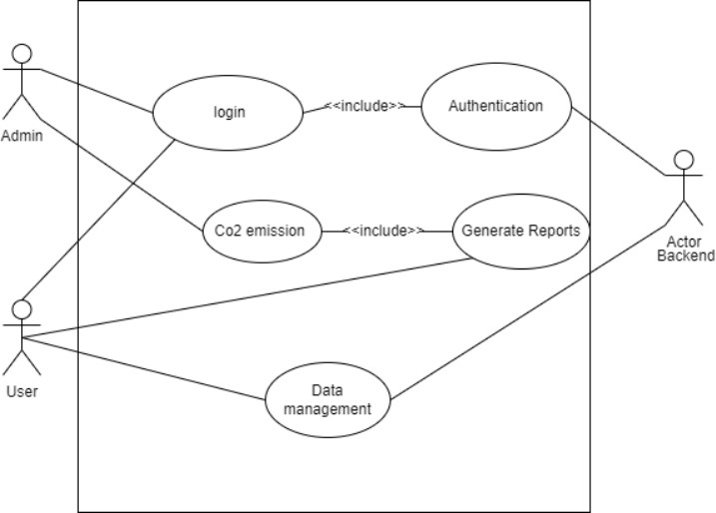

Figure 2.1: Use case diagram

Use Case descriptions using scenarios, strictly as per Pressman Template

Use Case 1: User Authentication
Description: Users should be able to register, login, and manage their accounts se- curely.
Primary Actor: User
Preconditions: None
Postconditions: Upon successful authentication, the user gains access to their account features.
Main Success Scenario: 1. User navigates to the registration or login page. 2. User provides necessary information (e.g., username, email, password). 3. System validates the information and creates/login the user account. 4. User gains access to their account dashboard.
Extensions: - If the provided credentials are invalid, the system prompts the user to retry. - Users can reset their password if they forget it, following the password recovery process.

Use Case 2: Data Input
Description: The platform must facilitate the collection of greenhouse gas emissions data from users, employing a guided questionnaire approach.
Primary Actor: User
Preconditions: User must be logged into the platform.
Postconditions: The collected emission data is stored securely in the system.
Main Success Scenario: 1. User navigates to the data input section. 2. User selects the type of emission data they want to input. 3. User provides relevant data values through a guided questionnaire. 4. System validates the inputted data for accuracy and completeness. 5. Validated data is saved securely in the system.
Extensions: - If the user attempts to input incomplete or invalid data, the system prompts them to correct the errors.

Use Case 3: Report Generation
Description: The software must generate comprehensive annual reports based on the input data, adhering to ISO 14064-1:2018 standards.
Primary Actor: System

Preconditions: Valid emission data must be available in the system.
Postconditions: Comprehensive annual reports are generated and made available to users.
Main Success Scenario: 1. System retrieves the required emission data. 2. System processes the data according to ISO 14064-1:2018 standards. 3. Comprehensive annual reports are generated. 4. Reports are made available for users to access and download.

Nonfunctional Requirements
      - Performance: The software should be responsive and scalable to accommodate concur- rent user interactions
      - User data should be encrypted and protected from unauthorized access.
      - The platform should adhere to ISO 14064-1:2018 standards and regulatory requirements.

Software and Hardware requirement specifications
The Software and Hardware Requirement Specifications outline the necessary software and hardware components for the greenhouse gas emissions reporting and annual report gener- ation platform. This document ensures compatibility, performance, and security standards, guiding the development and deployment process to meet organizational and regulatory needs efficiently.
- Response times for data retrieval and report generation should be within acceptable limits.
- The platform must respond to user interactions promptly, with minimal latency.
- User data must be encrypted during transmission and storage to prevent unauthorized access.

Chapter 3

PROPOSED SYSTEM
The Proposed System chapter serves as a foundational section within the document, delin- eating the rationale, objectives, and scope of the proposed greenhouse gas emissions reporting and annual report generation platform. It lays the groundwork for the subsequent sections, providing stakeholders with a comprehensive overview of the project’s goals, methodologies, and anticipated outcomes. By outlining the challenges faced by organizations in current emissions reporting practices and presenting the innovative solutions offered by the proposed system, this preamble sets the stage for a detailed exploration of the platform’s architecture, functionalities, and implementation strategies. Through a clear and concise presentation of the proposed system’s objectives and benefits, this chapter aims to garner support and consensus among stakeholders, fostering alignment and commitment to the project’s success.

Description of Proposed System.

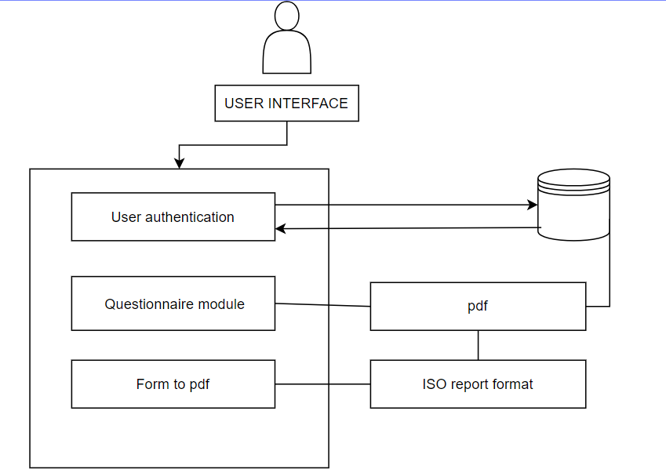

Figure 3.1: Proposed system

Authentication Module:
This module handles user authentication and authorization processes. It allows users to register, log in, and manage their accounts securely. Users can authenticate them- selves using credentials (e.g., username/password) or other authentication methods (e.g., OAuth). Role-based access control (RBAC) can be implemented to define user roles and permissions for accessing different functionalities within the platform.

Questionnaire Module:
The Questionnaire module guides users through the process of inputting greenhouse gas emissions data. It presents users with a series of questions or prompts to collect relevant information about emissions sources, quantities, and other related data. The module may include validation checks to ensure the accuracy and completeness of the inputted data. User-friendly interfaces and intuitive design elements are employed to enhance the user experience and facilitate data entry.

Form to PDF Module:
This module converts the data collected from the questionnaire into a PDF format suitable for report generation. It formats the data according to predefined templates or layouts specified by the user or system administrator. The module may include customization options for styling, branding, and layout configuration. Output PDF files may include charts, graphs, and other visual representations of the emission data to enhance readability and comprehension.

ISO Report Format Module:
The ISO Report Format module ensures that the generated annual reports comply with ISO 14064-1:2018 standards. It formats the emission data and other relevant information according to the structure and requirements specified in the ISO standard. The module may include validation checks to ensure that the generated reports meet the necessary criteria for accuracy and completeness. Output reports may include metadata, footnotes, and references to document the methodology and assumptions used in data collection and reporting.
The Figure 3.1

Description of Target Users
The Description of Target Users section provides a comprehensive overview of the intended audience for the greenhouse gas emissions reporting and annual report generation platform. By

identifying and understanding the characteristics, needs, and preferences of the target users, this section lays the foundation for designing an intuitive and user-centric system. Leveraging design principles such as usability, accessibility, and inclusivity, the platform aims to cater to a diverse range of stakeholders, including environmental professionals, sustainability man- agers, regulatory compliance officers, and other personnel involved in emissions reporting and management. Through a user-centered approach, the platform seeks to enhance user experi- ence, efficiency, and engagement, ultimately empowering users to navigate the complexities of emissions reporting with confidence and ease.

Advantages/Applications of Proposed System

    - Efficiency: Automates and streamlines the emissions reporting process, saving time and reducing administrative burden.
    - Compliance: Ensures adherence to ISO 14064-1:2018 standards, enhancing regulatory compliance and credibility.
    - Insightful Analysis: Provides tools for data visualization and analysis, enabling in- formed decision-making and strategic planning for emissions reduction.
    - Transparency: Promotes transparency by providing clear and accessible emissions data, fostering trust and accountability among stakeholders.
    - Cost Savings: Reduces costs associated with manual reporting processes, allowing organizations to allocate resources more efficiently towards sustainability initiatives.

Chapter 4

SYSTEM DESIGN

This chapter gives a brief description about implementation details of the system by de- scribing each component with its code skeleton in terms of algorithm.

Architecture of the system (explanation)
The architecture of the greenhouse gas emissions reporting and annual report generation system is designed to be modular, scalable, and efficient, ensuring seamless operation and reliable performance. Here’s an explanation of the system architecture:

Client-Side:

    - The client-side architecture encompasses the user interface components of the system, including web browsers or mobile applications used by users to interact with the plat- form.
    - The front-end is developed using React.js, a popular JavaScript library for building user interfaces. React.js facilitates the creation of dynamic and responsive interfaces that enhance user experience.
    - Client-side components communicate with the server-side through RESTful APIs, en- abling data exchange and interaction with the back-end services.

Server-Side:

    - The server-side architecture consists of the back-end components responsible for pro- cessing user requests, handling business logic, and managing data.
    - Node.js is used as the server-side runtime environment, providing a scalable and event- driven architecture that can handle concurrent connections efficiently.
    - Express.js, a web application framework for Node.js, is utilized to create RESTful APIs and handle HTTP requests, routing, and middleware integration.
    - MongoDB, a NoSQL database, is employed for data storage and retrieval. Its flexible schema and scalability make it well-suited for handling large volumes of emissions data.

Authentication and Authorization:

    - Authentication and authorization services are implemented to ensure secure access to the platform.
    - Users are authenticated using credentials (e.g., username/password) or other authenti- cation methods (e.g., OAuth).
    - Role-based access control (RBAC) mechanisms are employed to define user roles and permissions, controlling access to different functionalities within the platform.

Data Processing and Reporting:

    - The system includes modules for data processing, validation, and report generation.
    - Emissions data inputted by users is processed, validated, and stored in the MongoDB database.
    - Data processing algorithms may include validation checks, calculations, and formatting procedures to ensure accuracy and compliance with ISO standards.
    - A form-to-PDF module converts validated data into standardized annual report formats, adhering to ISO 14064-1:2018 requirements.

Class Diagram (with brief explanation)

User Class:

    - Represents a user of the system, who can log in, log out, and update their password.
    - Attributes include userId, username, password (hashed for security), and role (e.g., admin, regular user).
    - Methods include login(), logout(), and updatePassword().

EmissionData Class:

    - Represents greenhouse gas emissions data inputted by users.
    - Attributes include dataId, userId (to associate emissions data with users), emissionType (e.g., CO2, methane), quantity, source, and timestamp.
    - Methods include addEmissionData() to add new emissions data and getEmissionData() to retrieve emissions data for a specific user.

ReportGenerator Class:

    - Represents the module responsible for generating annual reports based on emissions data.
    - Attributes include reportId, userId (to associate reports with users), reportName, re- portContent, and timestamp.
    - Methods include generateReport() to generate a new report and getReports() to retrieve reports for a specific user.

Chapter 5

IMPLEMENTATION
The implementation of the greenhouse gas emissions reporting and annual report generation system involves developing a robust platform that automates data collection, validation, and reporting processes while ensuring compliance with ISO 14064-1:2018 standards. Leveraging Node.js and Express.js for the backend and React.js for the frontend, the system provides users with a user-friendly interface for inputting emissions data and generating reports. Data pro- cessing algorithms validate and format emissions data, while a form-to-PDF module converts it into standardized report formats. Through thorough testing, deployment to production environments, and comprehensive documentation, the system aims to streamline emissions reporting, enhance transparency, and facilitate informed decision-making for organizations committed to environmental sustainability. [1]

Proposed Methodology (Explain the methodology with diagrams/ Algorithms/flowchart explanation)
  - Description of Modules (Briefly describe important modules Modules descriptions Module Name : mod- ule( ) Input : Output : Describe Code/ Pseudocode/ flowchart

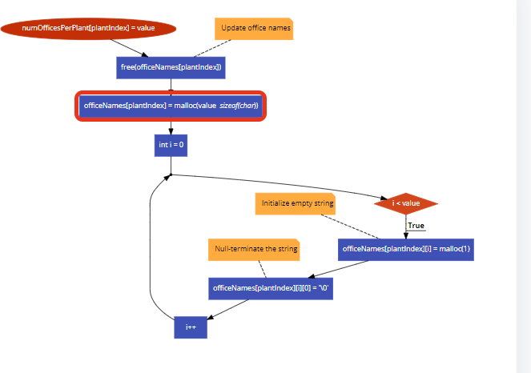

Figure 5.1: Algorithm flowchart

Algorithm 1 handleNumOfficesChange
Require: plantIndex, event
Ensure: Updated states reflecting the change in the number of offices per plant
1: Parse the value from the event and ensure it’s a valid integer. If not, default it to 0.
2: Update the state of the number of offices per plant:
3: a. Clone the previous state array.
4: b. Update the value at the index corresponding to the plant.
5: Update the state of office names:
6: a. Clone the previous state array.
7: b. Initialize an array of empty strings with the length equal to the new value.
8: c. Set this array as the value at the index corresponding to the plant.
9: Update the state of office electricity usage:
10: a. Clone the previous state array.
11: b. Initialize a 2D array representing electricity usage with dimensions [num- Plants][numOffices][12].
12: c. Set this array as the value at the index corresponding to the plant.
13: Update the state of office electricity bill:
14: a. Clone the previous state array.
15: b. Initialize a 2D array representing electricity bill with dimensions [num- Plants][numOffices][12].
16: c. Set this array as the value at the index corresponding to the plant.
17: Update the state of office electricity factor:
18: a. Clone the previous state array.
19: b. Initialize a 2D array representing electricity factor with dimensions [num- Plants][numOffices][12].
20: c. Set this array as the value at the index corresponding to the plant.

Chapter 6

TESTING

Testing is a crucial phase in the development of the greenhouse gas emissions reporting and annual report generation system, ensuring that the software meets quality standards, functions as intended, and is free of defects. Here’s an overview of the testing process:

Test Plan and Test Cases Explain in brief the types of testing done. Acceptance test plan test cases Unit test plan test cases

User Login (Acceptance Test):
    - Description: Verify that users can log in to the system using valid credentials.

Steps:
      - Navigate to the login page.
      - Enter valid username and password.
      - Click the login button.
      - Verify that the user is redirected to the dashboard.

Input Emissions Data (Acceptance Test):
    - Description: Validate that users can input emissions data accurately and efficiently.

Steps:
      - Navigate to the data input page.
      - Enter valid emissions data for different sources.
      - Click the submit button.
      - Verify that the data is stored correctly in the database.

Data Validation Function (Unit Test):
    - Description: Test the function responsible for validating emissions data inputs.

Steps:
      - Provide valid emissions data inputs.
      - Call the validation function.
      - Verify that the function returns true for valid inputs and false for invalid inputs.

Report Generation Function (Unit Test):

    - Description: Test the function responsible for generating annual reports.

Steps:
      - Provide sample emissions data inputs.
      - Call the report generation function.
      - Verify that the function returns a formatted report according to ISO standards.

Chapter 7

RESULTS DISCUSSIONS
(Discus the results and its interpretation. Snap shots with brief explanation about the results Summarize /Aanalyze the results)
Login page:
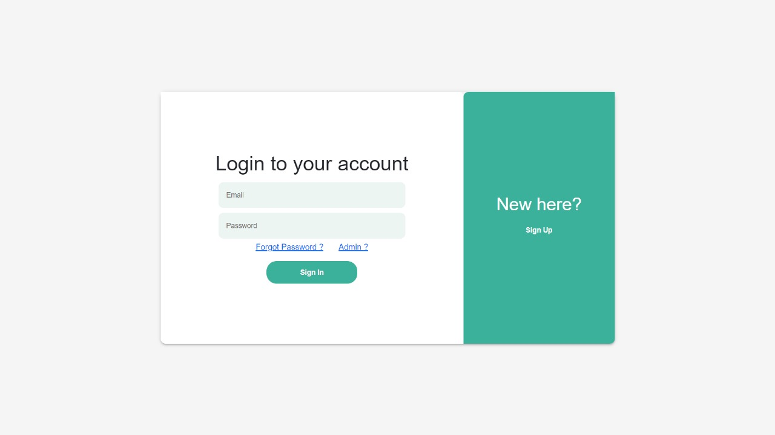

This page allows users to enter their email address and password in order to log in to the website. If a user does not have an account, they can click on the "Sign Up" link to create one. If a user forgets their password, they can click on the "Forgot Password?" link to reset it.

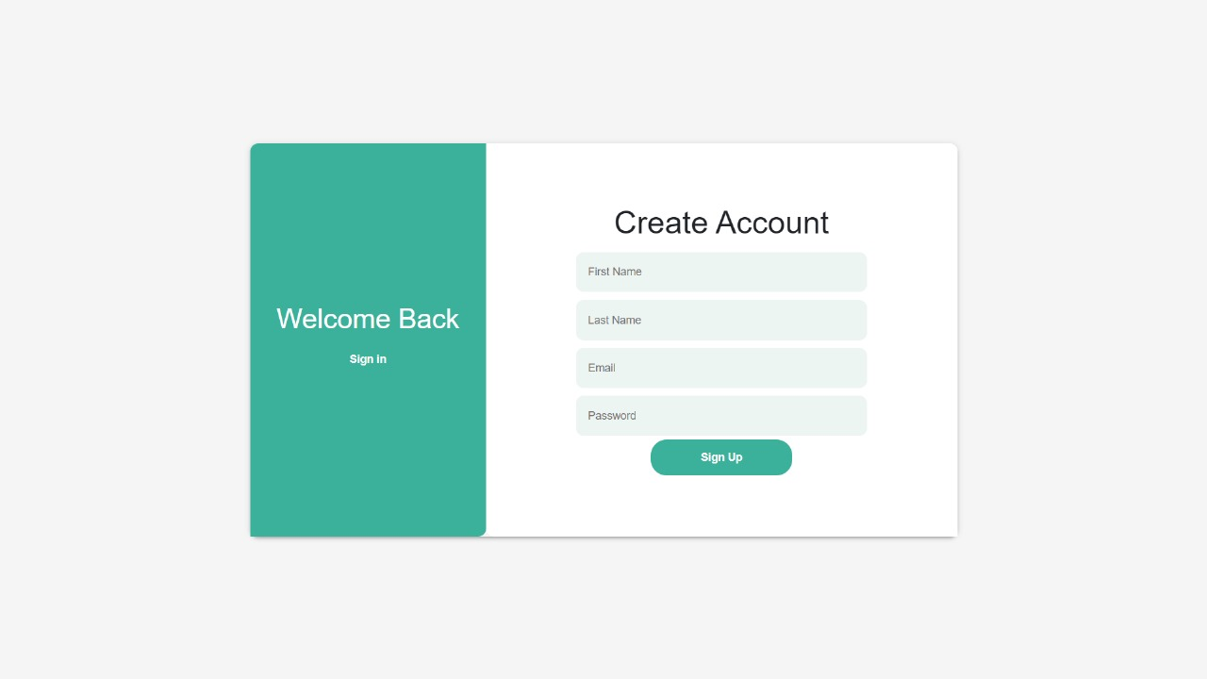

Sign In:

Create account page let new users register if donot have the account by providing info like firstname,lastname,email and password. They include input fields,and a sign-up button.

GHG reporting form:

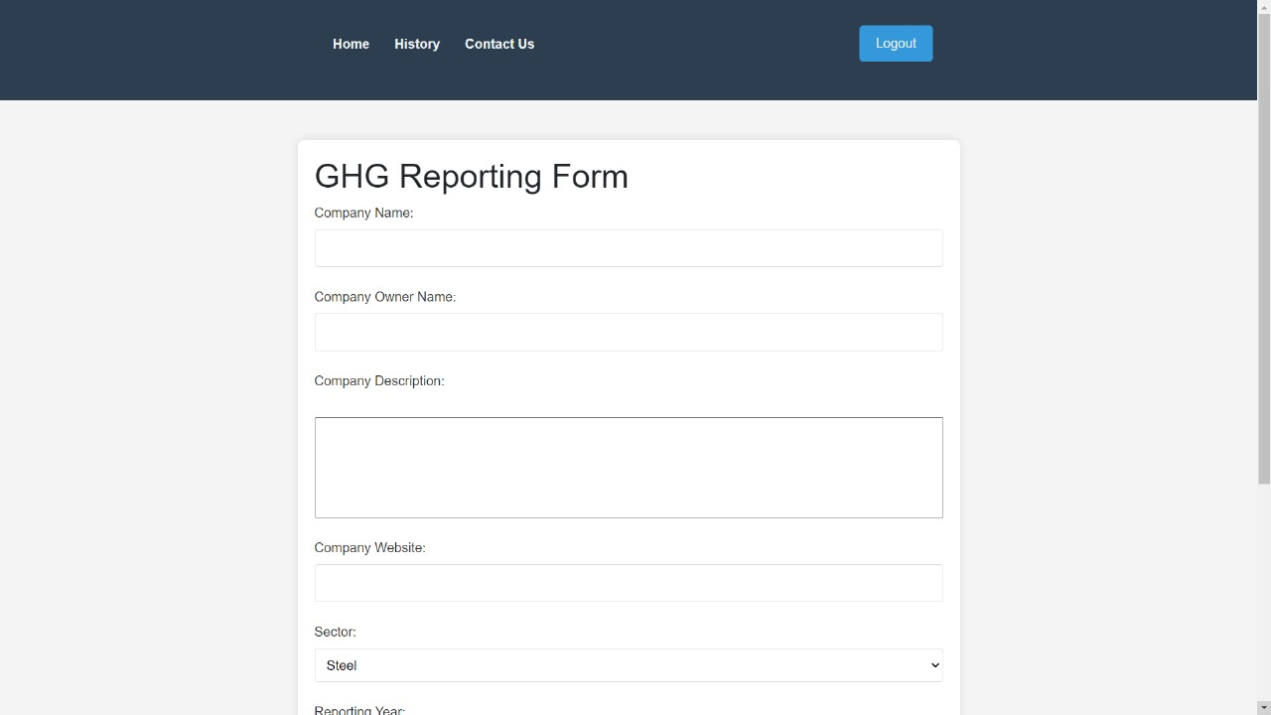

The user need to provide the details of the company like name, owner name, sector, reporting year for the final GHG report of the company with details analysis.Overall, the page appears to be designed to collect basic information about a company for the purpose of generating a report.

History of the user:

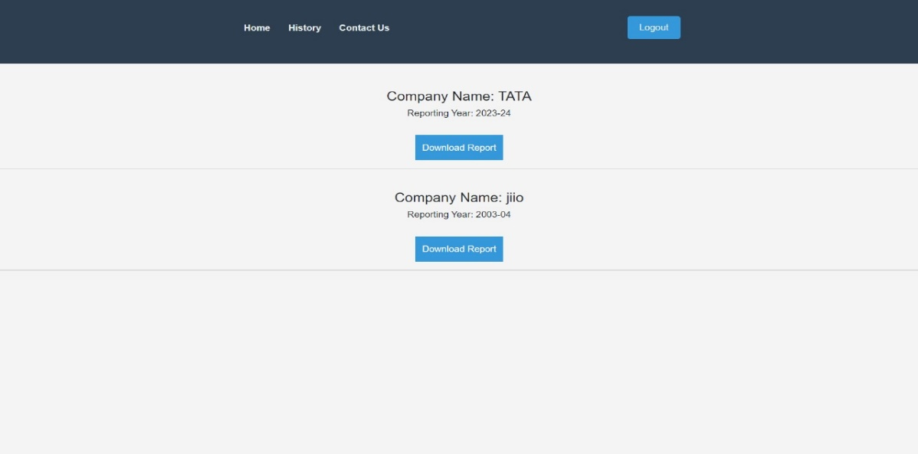

This page shows the history of the user pervious report generated by the user and can download and view.

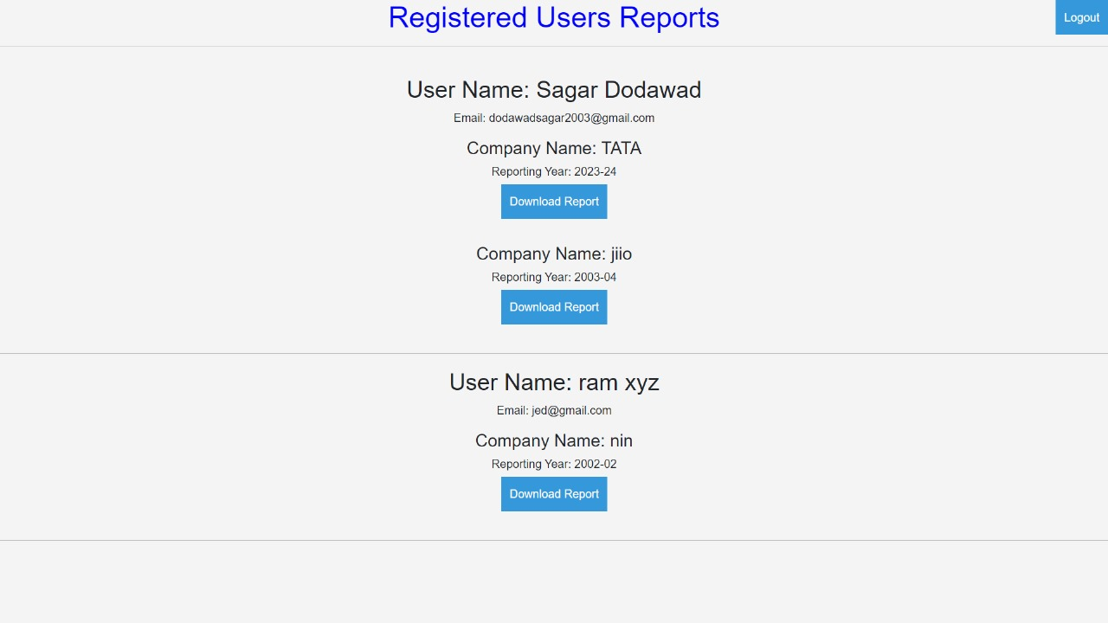
Admin side registered user reports:

This is the admin side page which admin can view all the report generated through the website and can edit the report if any changes to be done.
Chapter 8

CONCLUSIONS AND FUTURE SCOPE
Conclusion: The project undertaken by the School of Computer Science & Engineering at KLE Technological University has successfully implemented several key features and ser- vices. These include a robust user authentication system, efficient data input mechanisms for greenhouse gas emissions, and a comprehensive report generation module adhering to ISO standards. Through the development and integration of these functionalities, the project aims to streamline the process of emissions reporting, enhance data accuracy, and promote transparency and accountability in environmental management.
Future Scope: Looking ahead, there are several avenues for enhancing and expanding upon the work accomplished in this project. Future iterations could focus on integrating advanced data analytics capabilities to provide deeper insights into emissions trends and pat- terns. Additionally, the platform could be extended to support real-time monitoring of emis- sions data, enabling organizations to proactively identify and address environmental risks. Furthermore, enhancements in user experience and accessibility, such as mobile-friendly inter- faces and multilingual support, can broaden the platform’s reach and usability. Collaborations with environmental agencies and research institutions could also facilitate the integration of cutting-edge research findings and methodologies into the platform, further enhancing its effectiveness in promoting sustainable practices and mitigating climate change.

REFERENCES

[1] INTERNATIONAL STANDARD ISO 14064-1
The report is about establishing GHG emission boundaries, quantifying emissions and removals, managing and reporting GHG inventories, and the organization's responsibilities in verification activities.

[2] BlackRock's 2022 Greenhouse Gas (GHG) Emissions Report
It covers the information on the company's carbon footprint, detailing the amount of greenhouse gas emissions it produces and efforts taken to mitigate or offset these emissions and information about the emissions categories.

[3] Assessment of energy use and greenhouse gas emissions generated by transport infrastructure(Author-Sofiia Miliutenko).

Appendix A

Screen Shot

Login page:

Sign up page:
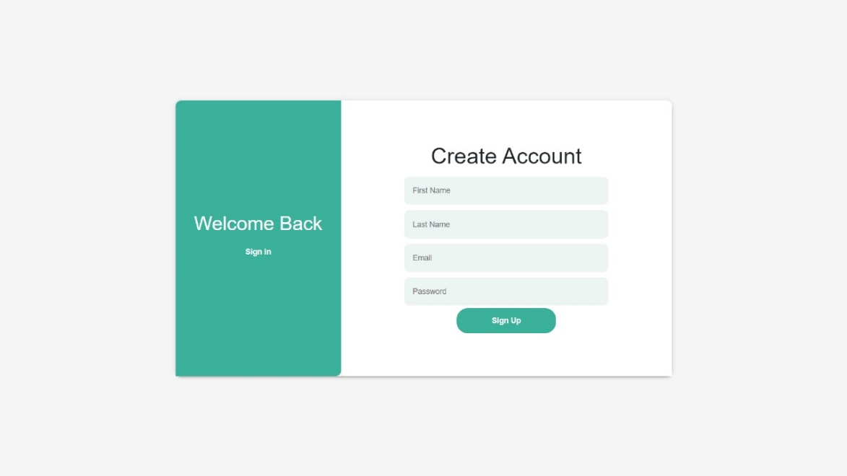

GHG reporting form:

User history:

Admin side registered users reports:

Glossary
Greenhouse Gas (GHG):
Gases in the atmosphere that trap heat, contributing to global warming. ISO 14064-1:2018: International standard for quantifying and reporting greenhouse gas emissions. MERN
Stack:
Full-stack JavaScript framework comprising MongoDB, Express.js, React.js, and Node.js.
MongoDB:
NoSQL database program for flexible data storage. Express.js:
Web application framework for Node.js, facilitating backend API development. React.js: JavaScript library for building dynamic user interfaces. Node.js:
JavaScript runtime environment for backend development. User Authentication: Verification of user identity for system access. Annual Report:
Comprehensive document summarizing emissions data over a specified period. Compli- ance:
Adherence to laws, regulations, and standards for emissions reporting. Validation: Verification of data accuracy and compliance with standards. ISO Standards: International guidelines for quality and environmental management.

Description of Tools and Technology used

Node.js:

    - A server-side runtime environment for executing JavaScript code, Node.js allows for the development of scalable and efficient backend services.

Express.js:

    - A web application framework for Node.js, Express.js simplifies the development of back- end APIs and handles HTTP requests and responses.

React.js:

    - A JavaScript library for building user interfaces, React.js enables the creation of inter- active and responsive frontend components, enhancing the user experience.

MongoDB:

    - A NoSQL database, MongoDB provides a flexible and scalable solution for storing and querying emissions data, supporting the system’s data management needs.

JavaScript (ES6+):

    - The primary programming language used for both frontend and backend development, JavaScript (ES6+) offers modern syntax and features for efficient and expressive code.

HTML/CSS:

    - HTML and CSS are used for structuring and styling the user interface, ensuring visually appealing and accessible web pages.

Git/GitHub:

    - Version control system Git and code hosting platform GitHub are utilized for collabora- tive development, enabling team members to manage and track changes to the codebase.

Postman:

    - Postman is used for testing API endpoints during development, allowing for the execu- tion of HTTP requests and validation of responses.

